End User Manual for CIED Information System

1 Getting started with iCARDEA CIED Information System 1
2 How to use CIED Data Integration 1
2.1 CIED data integration by retrieving Medtronic CIED PDF report through CareLink Webpage 1
2.2 CIED data integration with Merlin.net 4
3 Troubleshooting: Changing the Language of Medtronic portal to English. 6
4 Other troubleshooting 9

Getting started with iCARDEA CIED Information System
The iCARDEA CIED data exposure component presented in this paper employs standards specifications from ISO/IEEE 11073 (Health Informatics, Point-of-care Medical Device Communication) and HL7v2.x in the context of Integrating the Healthcare Enterprise (IHE) profiles to deliver telemonitoring CIED report data from two different CIED vendors to the adaptive care planner that implements guideline-driven care plans.
In this document it is described how to store a CIED report from Medtronic and SJM webportals has to stored , though iCARDEA CIED Information System can process them.

How to use CIED Data Integration
Note: Further information about Medtronic and St. Jude Medical CIED system and portals can be found at the iCARDEA Deliverable “D9.1.1 Requirement Specifications and Scenario of the Pilot Application”, available via http://www.srdc.com.tr/projects/icardea/index.php/component/docman/

CIED data integration by retrieving Medtronic CIED PDF report through CareLink Webpage

In the following the steps needed to download the CIED PDF files from CareLink web are presented.

- Open the Medtronic CareLink Webpage in a browser. Use a browser (e.g. Internet Explorer) to open the Medtronic CareLink Webpage and enter your credentials (e.g. https://europe.medtroniccarelink.net/Clinician/Login/Login.aspx, please refer to your hospital-IT for the correct web link)

- Chose the tab Transmissions and ensure that the View “Active Transmissions” is used. Select the patient and the report to be downloaded by clicking the checkbox on the left.

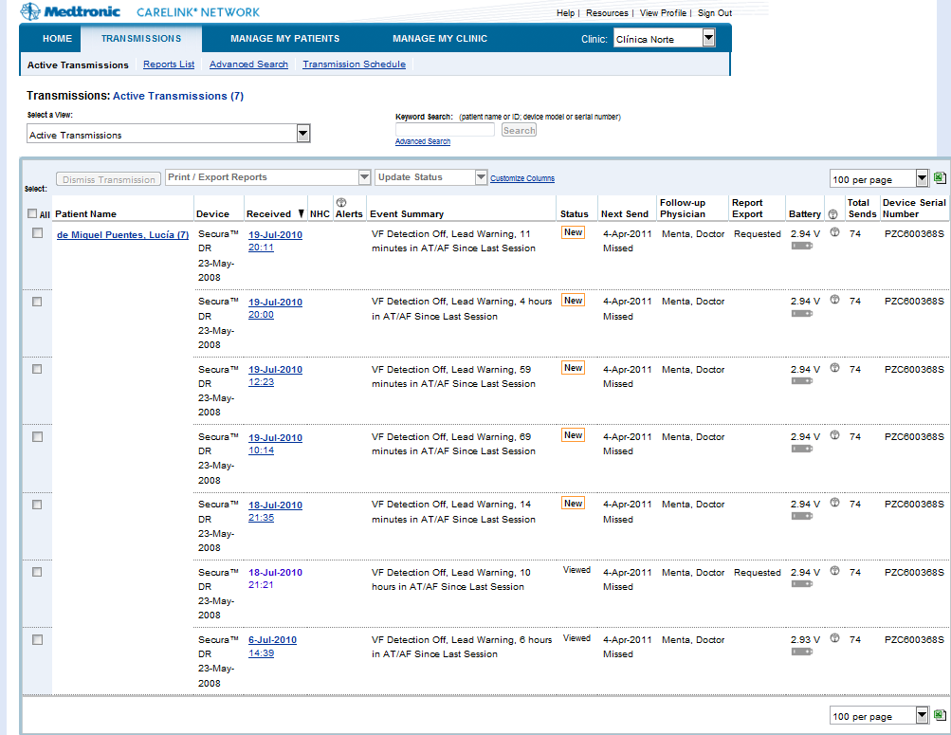

- Click drop down list “Print/Export Report” and select the “Export: Custom Reports” field

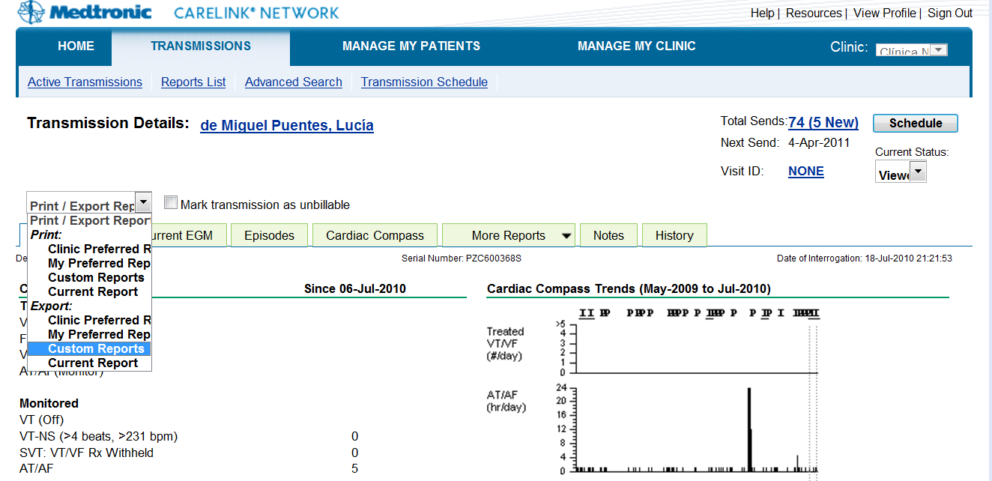

- In the “Request Custom Reports” ensure that the check box “ALL:” is marked for “Select:”. Then click “submit” at the bottom of the webpage.
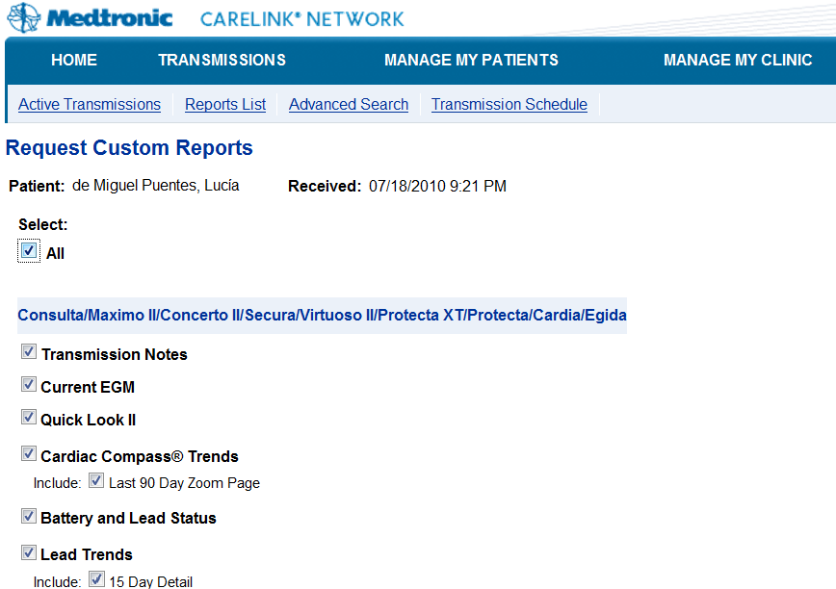

- At the “Transmission” webpage, choose the “Reports List” Click “Available to print”for the reports you want to store and a popup webpage with the CIED Report PDF will appear.

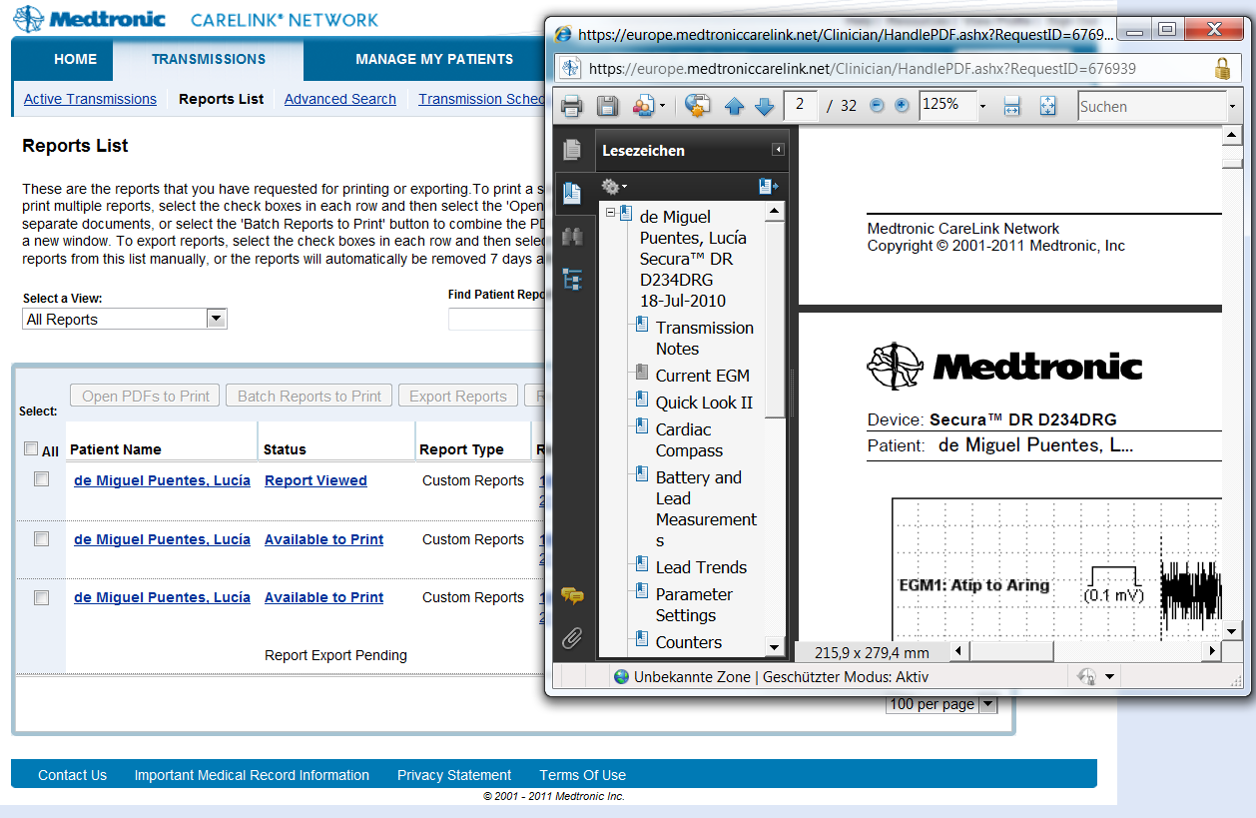

- Save the PDF files with an individual filename in the directory which was given to your hospital IT during the iCARDEA platform installation for Medtronic PDF. (At problems, please mention to the technical partner that the correct directory can be found in the iCARDEA configuration file “AppConfig.properties” indicated by DIRECTORY_MEDTRONIC_ORIGINAL_PDF_REPORT )
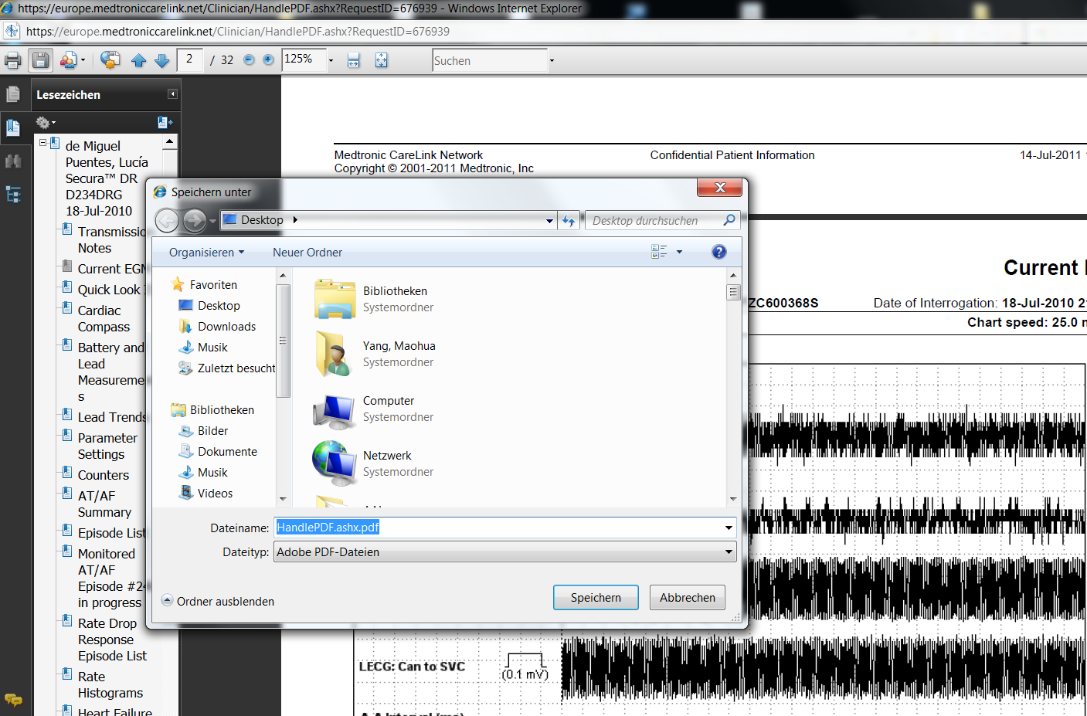

Note: Currently CIED Data Integration Module is only configured for PDF report in English language. Please generate PDF files from CareLink in English form. If you wish to use the German PDF

CIED data integration with Merlin.net

In the following the steps needed to download the CIED PDF files from Merlin.NET PCN web are presented.

- Open the St. Jude Medical Merlin.Net Webpage in a browser. Use a browser (e.g. Internet Explorer) to open the SJM Merlinn.Net Patient Care Network Webpage and enter your credentials (e.g. https://demo50.merlin.net/ please refer to your hospital-IT for the correct web link)

- If the “Recent Transmissions” is not shown on startup, select a Link indicating to access the patient data or arrhythmia & device management.

- At the “Recent Transmissions” select the reports to be downloaded by marking them on the right side.

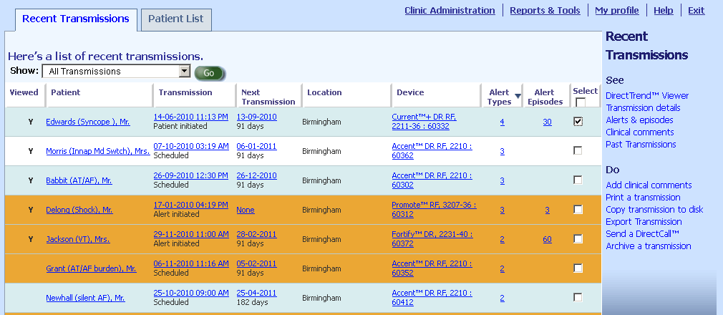
Then click “Copy transmission to disk”

- The following window should appear and ask for the directory to store the data. This is the directory which was given to your hospital IT during the iCARDEA platform installation for SJM Reports. (At problems, please mention to the technical partner that the correct directory can be found in the iCARDEA configuration file “AppConfig.properties” indicated by DIRECTORY_SJM_ORIGINAL_TXT_REPORT)

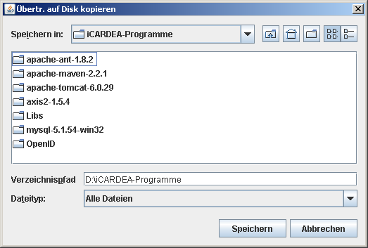

- This creates an folder for the patient and his specific report containing multiple files. This finishes the export of SJM reports. Please do not directly access theses files. To read them, please store them at a different directory.

Note: Currently CIED Data Integration Module is only available for Merlin.Net 5.0 in English language.

Note: You can see that the system is running, if a CIED-Report was stored to the directory and after some minutes the report was removed from the directory and moved to the processed folder.
If you login to the other iCARDEA components like CareplanManager or PatientParameterMonitor you should see new data obtained from the CIED-Report, indicating that everything went well.

Troubleshooting: Changing the Language of Medtronic portal to English.
Because Medtronic CareLink supports Multilanguage, users need to reconfigure language settings according to requirements.
Step 1: Choose the right clinic in “Choose Clinic” Drop-down List as shown in Figure 1.
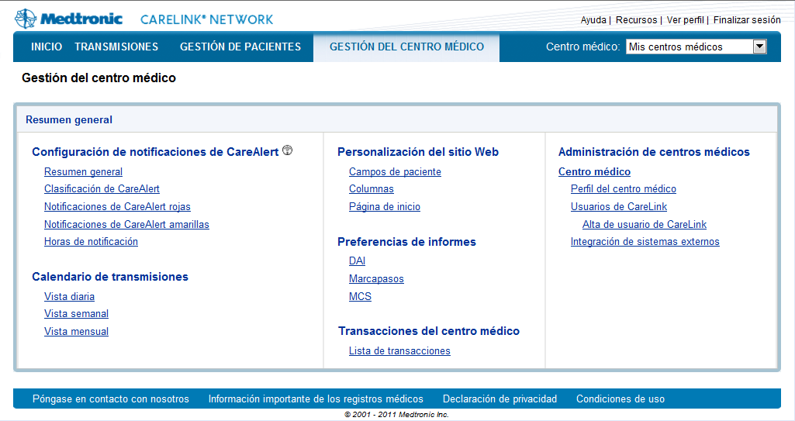
“Manage My Clinic”
“Clinic Profile”
”
Figure 1 CareLink-Main Page

In “Manage My Clinic” domain as shown in Figure 2, CareLink could be configured according to user requirements. In “Regional Setting” drop-down list, users could choose the right language and time format. In iCARDEA, it is set to “English, dd-mmm-yyyy, 2400” as Figure 3. After click “Save” button, the language in the CareLink webpage including exposure CIED PDF reports have been changed into English version as Figure 4.
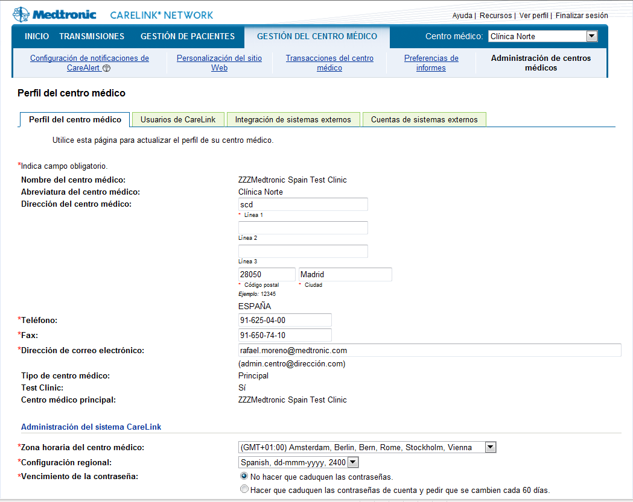
“Manage My Clinic”
Figure 2 CareLink Webpage-Manage My Clinic

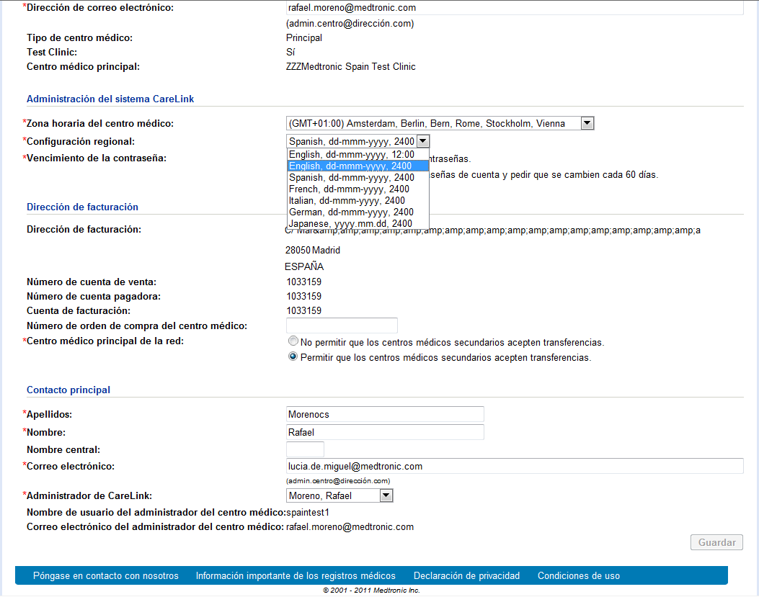
Choose expected language
“Save”

Figure 3 CareLink Webpage-Manage My Clinic-Choose expected language

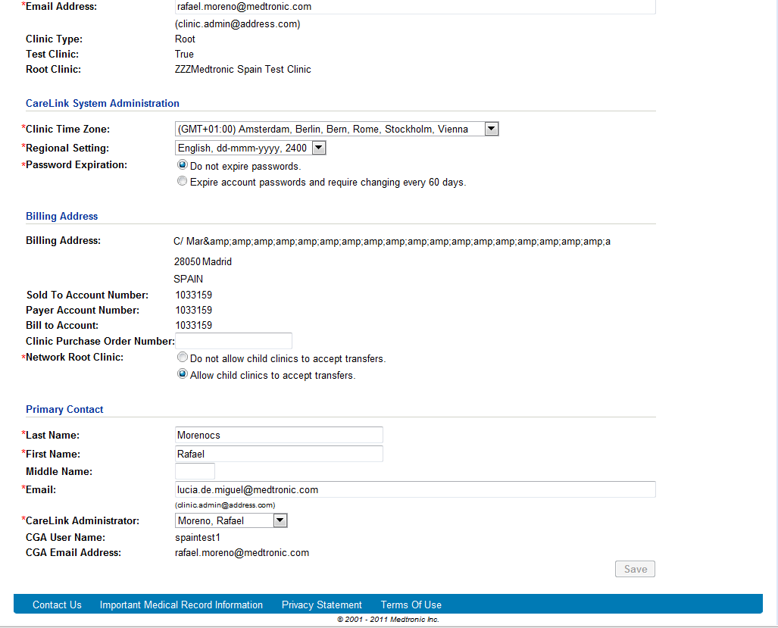
Figure 4 CareLink Webpage-Manage My Clinic-in Englisch

Other troubleshooting
Since the CIED Information system is not an end-user tool, there is no much troubleshooting you’ll can do.
You can see that the system is running, if a CIED-Report was stored to the directory and after some minutes the report was removed from the directory and moved to the processed folder.

